Please run Emma test coverage as shown below in eclipse

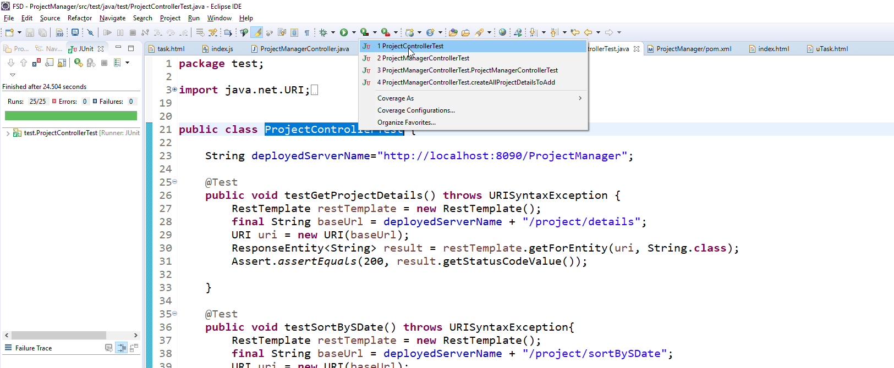

Once done we can see the report in eclipse as shown below.

